**Novel Cell Counting Algorithm and Image Processing for Cells *in vitro***

Daniel Amante, Jarel Cohen, Robert MacGregor, Ashutosh Priyadarshy

University of Virginia Biomedical Engineering Department, School of Engineering and Applied Science, 415 Lane Road, Charlottesville, VA 22908

*(received 13 May 2011)*

**Abstract**

Counting cells *in vitro* has always posed a unique challenge in biomedical research. While many devices currently exist that allow researchers to accurately count cells removed from a culture. However, for cells that remain in culture, the predominant gold standard for counting cells is manual visual counting, which is both tedious and time-consumings. Many different approaches have been developed to take an image processing approach to cell counting, but with limited success. This report describes an algorithm which counts cells to within 5-10% accuracy relative to manual counting. The image processing concepts of median filtration, histogram equalization, thresholding, and Moore neighbor boundary tracing were implemented and discussed. These concepts were placed into an algorithm designed to count cells in culture, from a bright-field image of the cell plate. After analyzing the algorithm with various images, the algorithm was successful in holding the accuracy goals for a variety of cell images, which ranged in size, shape, resolution, and confluence. The accuracy of using computer software was compared to ImageJ, a common tool in research labs that can be used for counting cells. The algorithm performed better than ImageJ in all tests; the algorithm had an average error of <10% and ImageJ rarely had an error that wasn’t greater than 100%. The concept of adaptability was also briefly discussed and implemented on a small scale. Future iterations of the code are theoretically discussed, leaving their implementation for future papers.

**Introduction**

Many different methods currently exist to count cells in culture. These methods have been developed based on the distinct parameters of culture conditions and varying growth of the cells. Cells that often require counting include but are not limited to: erythrocytes, leukocytes, neurons, bacteria cultures, and cells from known cell lines (i.e. Chinese hamster ovary cells and bovine aortic endothelial cells). When cells grow in vitro, they vary in the means by which they growth. Some will adhere to the dish in which they have begun to grow, eventually reaching an optimal density known as confluence. Others will grow in multiple layers. The cells are used for different forms of research, some in which they cannot be disturbed physically. This adds complexity to the cell-counting problem. Because of the inherent variability for the need to count cells in cultures, many marginally successful products have entered the market space. Some of these products, with both their advantages and disadvantages, are addressed below.

*Visualization by Eye*

The earliest form of cell counting is by pure visualization. This basic method is usually conducted by taking a microscope image of existing cultured cells or those fixed to a plate, and then physically counting the cells. This method is the most accurate of all cell-counting techniques for several reasons. First, the cells can remain in culture and a cell count can be obtained for each stage of the plate’s confluency of cells. Second, since the investigator is viewing the cells, an accurate distinction can be made by those cells that are healthy and those that are not viable. Third, the investigator is also able to determine regions where cells overlap on the culture dish, and make definitive conclusions as to the number of existing cells. However, the major disadvantage of this approach is that it is the slowest of all possible cell-counting modalities, and is highly dependent on the experience of the user.

*Hemocytometer*

The hemocytometer improves upon the ease of visual cell counting by providing protocols and a distinct apparatus for counting a cell sample. The hemocytometer contains a laser-etched grid of perpendicular lines mounted on a glass microscope slide. A specific volume of a solution containing cells is placed in the hemocytometer, and the number of cells is counted in several grids. This method can be used to estimate the total number of cells in solution if the volume is known. However, there are some potential pitfalls to this method, however. First, it is necessary to remove some cells from culture in this analysis, something that is not always possible in certain experiments. In addition, uneven mixing can significantly affect the density calculations. This can be minimized by counting cells in a number of grid points on the slide.

*Machines*

The Countess Automated Cell Counter from Invitrogen is a bench top automated cell counter. The machine not only performs cell counting, but viability and cell volume calculations. Its touch screen display allows data to be transferred to a USB drive and its relatively small size does not use much bench space. The Countess can measure cell concentrations from 104 to 107 cells per mL, with a mean cell diameter from 5 to 60 µm. To use the Countess, 10 µL of sample cell solution must be isolated and combined with 10 µL of trypan blue stain. A total of 10 µL of this solution is then inserted into the disposable cell counting chamber slide. By first focusing the image on the display screen of the machine, the cells are then counted and the following data is collected: total count, live count, dead count, and mean diameter. While the Countess is a quick and automated means to count cells, there are a couple negative features. First, cells must be removed from the environment from which they were growing, which is detrimental in some experiment set-ups. Second, since the counting slides are disposable, there is a large cost in performing frequent counts. Third, the concentration range that the machine can accurately quantify may limit its effectiveness in a particular study based on the type of cell and confluency of the sample[1].

The NucleoCounter is an automated cell-counting machine that is used primarily for mammalian cultures. This device combines the traditional approach of using a hemocytometer and microscope with fluorescence microscopy technology to determine cell concentration. The NucleoCounter uses disposable cassettes that are precoated with a fluorescent dye, propidium iodide (PI), which stains for the cells nuclei. With this approach, the system determines cell concentration without regard to cell morphology or size, increasing its ability to count all cell types. The cell samples are pretreated with lysis and stabilization buffers that dissolve cell aggregates and lyse cell membranes. The sample is then loaded into a disposable cassette and placed in the machine for 30 seconds while the nuclei are counted in the solution. While nuclei counting is accurate and fast, many researchers cannot use this machine because it requires their samples to be lysed. This would not be an effective cell counting mechanism for experiments that use a small number of highly specific cells. Furthermore, these cells would have to be removed from their cultured environment, causing further variations[2].

The Scepter 2.0 is a new Millipore technology that brings accurate cell counting to the culture hood. The Scepter is an automated cell-counting device that is built into a mechanical pipette. The Scepter cytometer provides users with detailed histograms and numerical statistics and capabilities of accurately counting every cell in the sample, including those with diameters less than six µm. This cell counter uses the Coulter principle of impedance-based particle detection to accurately count every cell in the sample. First, a specific volume of cell suspension is drawn into the Sceptor sensor. Second, the cells are able to flow through the aperture in the sensor, which increases the resistance and voltage of the inner circuit. The voltage changes are recorded as spikes with each passing cell, which are used to give a final cell count of the sample. The Scepter 2.0 allows investigators to count cells directly under the culture hood, but also requires them to disturb their cell cultures in ways that can disrupt ideal conditions.

While each of these cell-counting apertures is widely used in the scientific community, they all require the cells to be removed from their culture conditions. In many experiments, this procedure is appropriate and will not negatively affect the outcome of the study. However, for those investigators that culture cells which cannot be disturbed or removed from their cell plate surface, these machines are not an option[3].

*Estimations (ImageJ)*

More recently with advancements in computers, programmers have begun to create algorithms to replicate the ability of the human eye to identify cells while minimizing the possible negatives of the long counting time and inaccuracy. ImageJ, an imagine processing program used in conjunction with high-powered microscopes, has programs that count cells in an image. Once the user has acquired a biological experimental image, the automatic particle analysis requires the image to be a binary image (black or white). In order for the program to function properly, it needs to know exactly where the edges are to perform morphology measurements. The user can set a threshold range, changing all those pixels with values within the range to black and the pixels with values outside of the range to white. Once this is completed, the image is filtered and the particles are counted. The advantage of using this cell counting function in ImageJ is that the cell sample can remain in culture as long as a clear image can be acquired. However, the major problem with this program is with its inaccuracies in determining total cell count with cell cultures of high confluency. Since the program recognizes distinct edges of cell morphology change, the cell samples that are confluent and contain overlapping cells cause cell count discrepancies.

*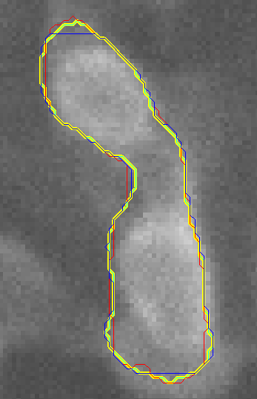Challenges associated with cell counting*

While the notion of counting cells sounds relatively simple, computers have historically struggled to accomplish the task. The issues stem from a variety of circumstances that severely limit the method by which cells can be counted. These issues are both biological, including the closely packed cells resulting from confluence, the nature of cell biology and the existence of organelles, and the random orientation of adhered cells, as well as imaging issues, including resolution, lack of apparent cell boundaries, and speckling.

The primary challenge results from confluence. Confluence results in vitro when cells are allowed to divide until they cover the entire available surface, for instance a Petri dish. The cells are forced into such close contact that no space exists between them; that is to say, one cellular membrane will appear to divide two cells, rather than a membrane, empty space, and a second membrane barrier. This phenomenon severely inhibits the technique used by the popular cell-counting program *ImageJ,* which functions by tracing the outer-contours of cell. In this situation, when confronted with abutting cell membranes, the contour-trace may err and follow the wrong path by tracing the outside of two cells. Figure 1 above, for instance, displays two distinct cells counted by the program as one. *ImageJ*, due to confluence, may thus underestimate the number of cells present in a sample.

**Figure 1**: An image of two cells which have been improperly counted as one. Note that due to the lightened gray area between the two cells and the particular threshold value used, a boundary connects the two cells instead of having two separate boundaries.

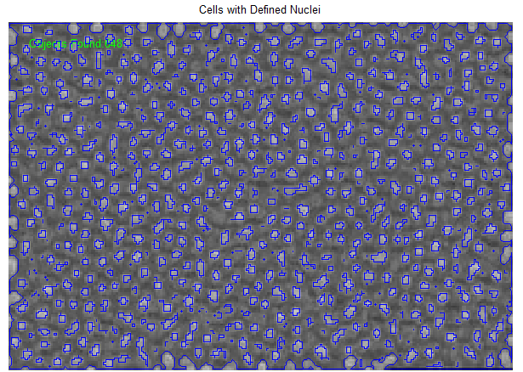One possible alternative to *ImageJ* attempted to use the built-in MATLAB function “bwboundaries” (Moore Neighbor - add) in coordination with thresholding to produce an accurate cell count. This function will highlight and count boundaries (rather than trace), potentially eliminating the double count. A complication in this method arises in the presence of organelles. Cell organelles, the functional bodies within cells, may have membranes of their own and appear to be cells themselves. This problem is small when the predominant organelle is the nucleus, as in Figure 2. The program counts the nuclei, almost to the exclusion of the whole cell. A few other organelles are counted, producing a slight over count. However, as these cells have only one nucleus each, and as the actual cell exterior is too faint to register, the count is fairly accurate. If the exterior were outlined as well, the parameter ‘noholes’ could be implemented, which would prevent an outline from forming within another outline and ensure that either the nucleus or the whole cell are counted, but not both.

**Figure 2**: An image cells with boundaries that preferentially surround the nucleus instead of the cellular membrane. Since these cells contain one, well defined nucleus, the overall count of cells is accurate.

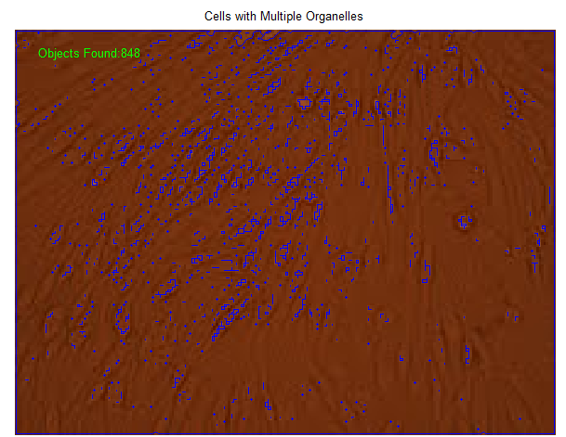

The method breaks down, however, when other, well-defined organelles exist. Bovine endothelial cells (BECs) are a very popular type for cellular research. Due to the widespread use of these cells in studies, the algorithms in this paper were applied primarily to BECs. Typical BECs, as displayed in the Appendix (figure Xx), contain a series of smaller organelles within the main cell body. The basic bwboundary command, applied with the thresholding, appeared to outline these smaller organelles within the cell and add them to the total cell count, as shown in Figure 3. The cell count was thus expected to yield a dramatic overestimate. The returned value of 848 objects was nearly a five-fold increase from the hand-counted value of 170 cells.

**Figure 3**: An image cells with boundaries that preferentially surround organelles instead of the cellular membrane. Since these cells contain a variable amount of poorly defined organelles, the overall count of cells is inaccurate.

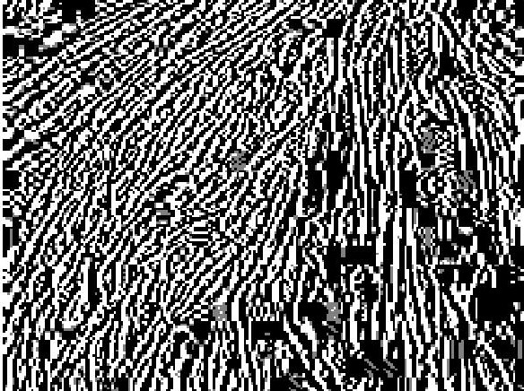An additional method to resolve cell boundaries in order the facilitate counting involved the use of gradients. Cell boundaries, be they with the background, or else between two confluent cells, represent a location where the pixel values rapidly change. Ideally, these large gradient values would provide an adequate parameter to be counted. The presence of organelles, as well as artifacts in the form of specks on the images themselves, rendered the ability of this method to provide a count, however. As shown in Figure 4, a gradient image from the Appendix A, high gradient values corresponded not only with the cell boundaries but also with all boundaries. While the gradient method cannot be used to count cells, it does however provide a reasonable overview of the general orientation of cells.

**Figure 4**: A gradient map of a figure in Appendix A in the appendix. Note that gradients in intensity appear for not only cell membranes, the ideal, but also for organelles, particles, and lighting variations.

*Published Works*

While the task of efficiently and accurately counting cells in cultures that do not allow for removal from growth surfaces remains a challenge, some scientists have been able to use specific cell counting algorithms and image processing techniques to quantify their cell cultures. Markiewicz et. al used Computerized Analysis of Microscopic Images (CAMI) design software to digitally reconstruct the diversiform glands seen in chronic inflammatory gastric mucosa[4]. With CAMI visualization, the group stained the selected cells to recognize the cytoplasmic immunoreactivity. A sequential thresholding algorithm combined with an artificial neural network was used to spot the unstained cells for analysis. This technique was effective in accurately quantifying and reconstructing those cells, which had been stained, but faced difficulties due to the inherent analysis of a more spatial distribution of immunostained cytoplasm in contrast to those cells, which remained unstained.

Bewes et. al proposed an automated cell colony counting method that was both flexible and capable of providing an in-depth clonogenic analysis[5]. The group used the full form of the Hough transform, which uses template matching to group pixels into colony candidates. After initial image preparation to define the cell colony, the colony edges were identified by intensity gradient field discrimination. While this approach was effective in identifying colonies with unusual morphology and merged colonies, its computationally intensive step of calculating entries in an accumulator array was not ideal.

Researchers at Harvard Medical School developed an algorithm for automatic cell counting in microwell arrays. Their work, called Arraycount, consists of cell imaging using a fluorescent microscope in microwell arrays[6]. Green and red fluorescent images were extracted and a template-matching algorithm was used to determine local maxima in fluorescence compared to correlation maps. The software they recorded the cell counts for each microwell in the original image. While this method produced automatic counting results only 2.5 to 3% different from manual counting, it does require the cells to be plated in microwells prior to imaging.

Zhou et. al used optical microscopy to produce an effective automated, quantitative analysis system that was used to track, segment, and quantize cell cycle behaviors of a large population of cells nuclei efficiently[7]. Their approach used both the watershed algorithm and adaptive thresholding to segment cell nuclei. The phases of cell nuclei were identified using the Markov model based on the information of time-lapse data. Their results proved successful in analyzing nuclei segmentation and cell phase identification. Other cell segmentation studies used a unitone conversion to obtain a single-channel image with high contrast. From these images, which contained a bimodal distribution due to H&E-stain, a cell-likelihood image was created.

Researchers used human embryonic stem cell (hESC) cultures to identify a fast and consistent method for in situ automated hESC population estimation to quantitatively estimate cell growth[8]. Each cell was fixed and stained for nuclear proteins, and imaged using high-resolution microscopy. Their analysis used a watershed operator to split most physically overlapping nuclei. This manipulation led to a pixel area distribution of isolated signal areas on the image. With this distribution, the group derived the nucleus area model, which identified the distribution of the area of cell debris, single nuclei, and small groups of collected nuclei. This method was successful in producing automated counting results with 6% error compared to manual counting.

Finally, Ruggeri et. al produced a computer program for the automatic estimation of endothelium morphometric parameters in alazarine red-stained images. The group imaged samples of corneal epithelium stained with alizarin red using an optical microscope[9]. The images were then pre-processed to improve contrast and luminosity. An artificial neural network with local shift invariant interconnections was then used to obtain a binary classification of the image pixels. Based on the contour images, the group derived the area and number of sides of all detected cells. Even though the proposed system demonstrated a long processing time, the results produced quantitative measurements with less than 3% difference to manual 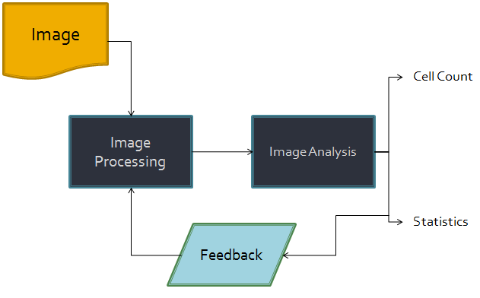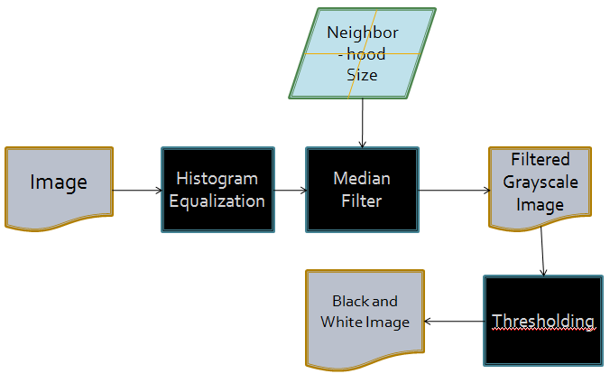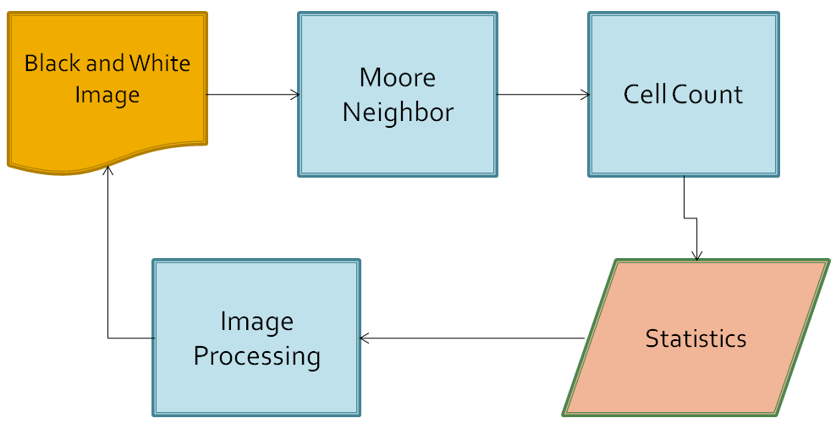counting.

**Results and Discussion**

Our proposed cell-counting algorithm implements multiple image processing techniques along with statistical analysis to accurately count cultured cells in an image. Once an image has been acquired using a specific objective under a light microscope, the image is first prepared by removing all unnecessary noise and speckling that would cause difficulties in resolving individual cells. A median filter, a nonlinear digital filtering technique, was used to remove random high intensity pixels that cause distortion and maintain cell membrane edges. Optimizing the reduction of speckling and preservation of cell resolution was a necessary component during the initial filtration step. Once the median filter was applied, histogram equalization was used to enhance the image contrast and provide better cell membrane resolution. Thresholding was then used as a means by which defined borders could be established based on pixel intensity values above and below a specific optimal range. Once all image processing was conducted to enhance the distinct cell borders, the Moore neighborhood algorithm was used to count the individual cells. Each iteration of the Moore neighborhood algorithm traced the cell boundary and produced unique cell outlines that were then counted.

**Figure 5**: Cascaded architecture of the created algorithm. From top to bottom: a high level view of the basic processes with feedback loop, the image filtering process, the cell counting and reparameterizing process.

*Overview of the Algorithm*

Earlier we have described the fundamental issues in counting cells, specifically bovine endothelial cells. To this end, we have developed a methodology that will be capable of addressing these issues and improve upon them by accurately counting cells. The cell-counting algorithm we have developed is described by the cascaded architecture displayed in Figure 5. The algorithm implements multiple image-processing techniques along with statistical analysis to accurately count cultured cells in an image.

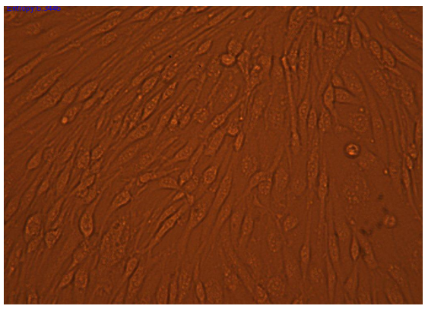First, an image must be acquired using a specific objective under a light microscope (Figure 6). The image is first prepared by removing all unnecessary noise and speckling that would cause difficulties in resolving individual cells.  A median filter, a nonlinear digital filtering technique, was used to remove random high intensity pixels that cause distortion and maintain cell membrane edges.  Optimizing the reduction of speckling and preservation of cell resolution was a necessary component during the initial processing step.  Once the median filter was applied, histogram equalization was used to enhance the image contrast and provide better cell membrane resolution.  Thresholding was then used to define borders based on pixel intensity values above and below a specific optimal range.  Once all image processing was conducted to enhance the distinct cell borders, the Moore neighborhood-tracing algorithm was used to count the individual cells. Each iteration of the Moore neighborhood algorithm traced the cell boundary and produced unique cell outlines that were then accumulated in a data structure. The final step of the algorithm analyzes the statistics of the cells accumulated in the data structure and is able to dynamically adjust its count for errors in the Moore neighbor-tracing algorithm.

Figure 6: A representative image of Bovine Endothelial Cells used for explaining the image processing that occurs within the algorithm

In conjunction with a detailed discussion of the algorithm, we trace through the algorithm with the use of a representative BECS images. The use of the representative image will illuminate and exemplify the properties of the methodology we have developed. Figure 6 shows this representative image of bovine endothelial cells. This image is of interest to us because it displays both cells in confluence and cells not in confluence. Furthermore, we notice that cells are more or less randomly oriented and there is a reasonable variability in cell sizes. In addition, as we discussed earlier, these cells are littered with organelles another characteristic problem in cell counting.

*Initial Filtering*

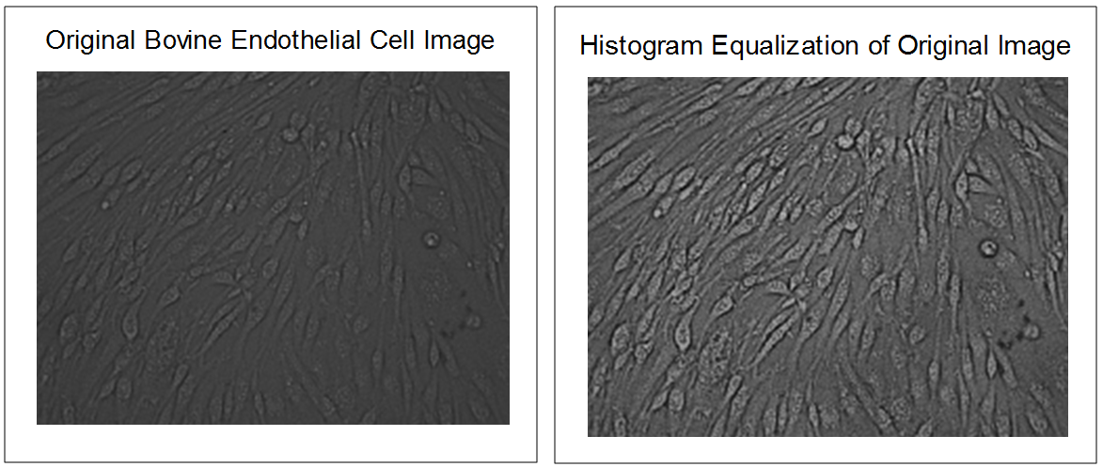 As discussed previously the properties of cell images are not congruent with the requirements of the simple Moore-Neighbor tracing algorithm. In order to meet these needs we apply both a median filter and adaptive histogram equalization filter to the image multiple times. Appendix B verifies that there is no discernable difference in images that are filtered by the adaptive histogram filter multiple times followed in series with several median filtration cycles and those images that are filtered in multiple cycles of adaptive histogram equalization and median filtration one after another.

**Figure 7**: From left to right: A representative image of Bovine Endothelial Cells in grayscale, and that same image which has been equalized over the intensity spectrum to improve contrast

The need for adaptive histogram equalization arises from the lack of contrast in the initial images. Adaptive histogram equalization is the approach of choice to increase the contrast because it changes the contrast of the image in a section-wise fashion. Due to the non-homogenous lighting conditions these images are subjected to it becomes favorable to use adaptive histogram equalization. Figure 7 compares the original grayscale image with the same image histogram equalization. From this, we can see qualitatively that the contrast has increased, if we look at the intensity histogram of the filtered image we will find that the contrast has increased quantitatively as well. After applying this filtering technique we have achieved more defined borders in the image; this comes at the cost of increased borders around speckles, non-cell objects, and organelles.

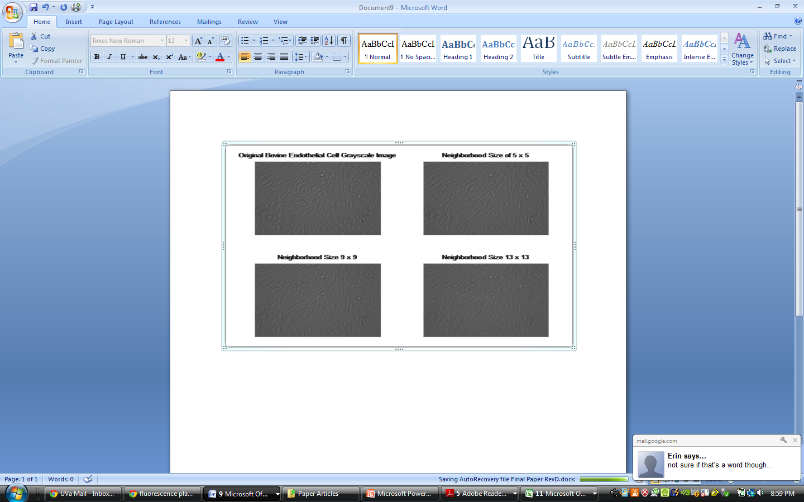The adaptive histogram equalization method leaves much to be desired for the simple contour tracing we will use to count the number of cells in the image. The next step in the filtration process, median filtration, morphs the image into something that can be binary-thresholded and finally counted by the Moore-Neighbor function. Qualitatively, the median filtration has the effect of blurring the image; the traditional use of this filter is to remove salt and pepper noise in an image. This is highly desirable because in context of a BECS image this blends organelles into cell bodies and deteriorates the impact of speckling outside of cell boundaries. Figure 8 shows how the original image becomes smoothed and the obvious reduction of speckling and degradation of organelles. Analytically the median filter selects a pixel and assigns to it the median pixel value from a specified neighborhood around the image. The effects of neighborhood size are explored in detail in our discussion of further research.

**Figure 8**: From left to right, top to bottom: A representative image of Bovine Endothelial Cells in grayscale, and that same image with a neighborhood size of 5, 9, and 13. Note the increased “blurring” in images with larger neighborhood sizes.

*Thresholding*

After undergoing the filtration process, the grayscale image is ready to be thresholded and turned into a black and white image. Thresholding is the simplest form of image processing used in the algorithm, and is used in the code to transform an 8-bit image into a binary image. The focus of this part of the code is the definition of the threshold value, which can vary widely from image to image and even within an image. The threshold value determines which pixel values will be assigned to black (0 in binary) and which pixels values will be assigned to white (1 in binary). For this algorithm, it is most prudent to set the threshold in such a way that cells 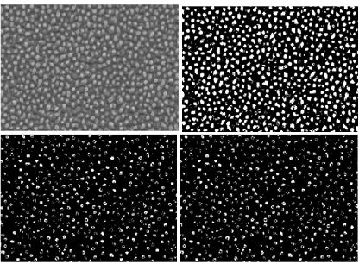are defined to be white while all background is defined to be black. Figure 9 shows the variation of a global threshold value on the resulting binary image that is sent to cell counting. Note that with a threshold value too low, background noise is labeled as cells, and with a high threshold value, cells are labeled as background noise.

**Figure 9**: From left to right, top to bottom: A representative image of BAECs in grayscale, and that same image with a threshold value of 128, 160, and 224. Note how higher thresholds tend to produce multiple white boundaries per cell, while lower thresholds tend to produce one boundary for multiple cells.

Several different factors make this more difficult than it initially appears. First, since most cells are imaged under intense lighting in order to be visualized with any degree of resolution, and since this intense lighting comes from a bulb, meaning the intensity varies with distance from the center of the bulb, a halo can be generated. These halos cause an unnatural bright spot in the image and can be detrimental to the thresholding process. While this is an artifact of the image, and is difficult to remove without extensive calculations, its effects can be minimized using dynamic thresholding that will be discussed in the further research section of the paper. Second, because of how the algorithm is created, it will only count white cells on a black background; it will not count with any accuracy black cells on a white background. This obstacle is easily surmounted with the use of image inversion, which was performed manually for this iteration of the code. The future research section of the paper describes different methods to automate this process. The most current iteration of the algorithm takes a user input for the thresholding value in the command line.

This value usually ranges between 190 and 220 (out of 256) for the imaging of a white cell on a black background. A threshold value of 190 is used for darker images while a threshold value of 220 is used for brighter images.

*Cell Counting*

Once an image has been properly filtered to remove noise and highlight the cell against a background image, then thresholded and transformed into a binary image, it is ready to be counted. This algorithm uses the Moore neighborhood algorithm to find a contour map of each cell. In MATLAB, the Moore neighborhood algorithm is called using the bwboundaries function with the no holes option activated. The Moore neighborhood takes a pixel, searches it eight closest neighbors equidistant from the chosen pixel, and searches for a black pixel to jump to next. In this way, the algorithm “traces” around the outside of each white cell clockwise until it returns to its starting point. The Moore neighborhood algorithm returns a series of (X, Y) points denoting boundary pixels of that particular cell. This process is repeated for every cell. By then end of the implementation of the Moore neighborhood algorithm, there is an array of boundaries, with each boundary containing a series of points that defines it. Each boundary is integrated to find the area of the cell using MATLABs trapz function. These areas are fed into a list that is correlated to each boundary.

These boundaries are then filtered by size to further reduce the amount of salt and pepper noise that may have made it past the filtering and to correctly identify which larger boundaries are actually two cells that have been “muddied” together and which are actually bright background that needs to be filtered out of the final cell count. The mean and standard deviation are taken of the area data, which were calculated earlier. These statistics are then used to determine a minimum cell size, an optimal cell size, and a maximum cell size. Boundaries with areas smaller than the minimum are deemed noise and as such are not added to the cell count total. Cells above the optimum cell size but below the maximum cell size are determined to be two cells that, through filtering, now constitute one boundary. The written algorithm counts cells in this size range as two cells. Cells above the maximum are usually a boundary created by a bright spot in the background and as such are not counted.

After counting has been completed, the results are displayed both pictorially and numerically for the user to ensure that the correct cells have been counted and that good filtering values were used in the algorithm. In the most current iteration of the algorithm, the statistics of the cell boundary data is used to compute new neighborhood sizes, new numbers of repetitions of median filtering, new thresholding values, and a new mean and standard deviation of cell size. This reparameterization of the image is accomplished through the comparison of a ratio between the standard deviation and the mean. The optimal value of this ratio depends on certain factors of the image including the average number of pixels per cell and the relative confluence of the image. Smaller cells with increased confluence lead to higher optimal ratios, while larger, less confluent cells are optimized at lower ratios. The user currently inputs the optimal ratio, and the program iterates until the desired ratio is achieved. See the further research section for possible automated implementations of this portion of the algorithm.

*Comparison of ImageJ, the algorithm, and manual counting of cells*

Relative and absolute efficacy of our algorithm was found by comparing the results to both manual counting of the cells in an image and the resulting counts by analyzing the images with the counting feature of ImageJ. In general, it was found that ImageJ provides a very inaccurate count of cells in an image while the algorithm very closely compares to manual counting of cells, which in this test was considered the gold standard of accuracy. Three different images were analyzed, which contain a variety of different features that can vary during cell growth such as cell shape, cell orientation, overall cell size, average number of pixels per cell, and relative confluence of cells.

*Sample 1:*

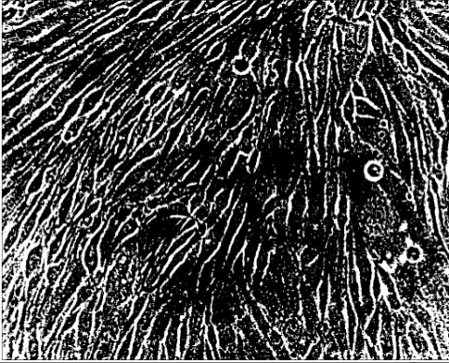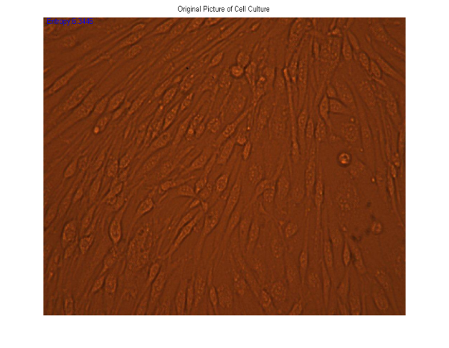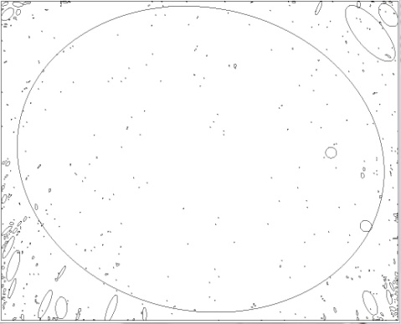 Sample 1 consisted of a sub-confluent colony of BECs, which were non-spherically shaped cells in a variety of orientations. A manual count of 217 was obtained for this sample. Using ImageJ, the image was thresholded, converted into a binary image, and then the resulting particles were analyzed and counted. ImageJ returned a cell count of 519, which is greater than 100% error. Looking at the resulting image of what ImageJ considered cells, the majority of circled boundaries are much too small to be cells. These “speckles” could be either the result of salt-and-pepper noise in the image or the increased brightness of the organelles present in the cell. In the extreme corners of the cell, ImageJ appears to do a relatively decent job of finding the cells, though the exact reasons why are unclear. Another baffling result of the ImageJ calculations is the large cell, which takes up almost the entire center of the image. See Figure 10 to compare the original image with the cell counts that ImageJ reproduced.

**Figure 10**: From left to right, top to bottom: A representative image of BECs, that image thresholded, the algorithms result of 208 cells, and ImageJ’s result of 519 cells, compared to a manual count of 217 cells.

The algorithm under test provided an initial cell count of 625, which was on par with the error associated with ImageJ, but through filtering and the iterative parameterization of the image, the final filtered cell count was 208, which constitutes a 4% error in counting. This falls well within normal deviations of manual counting of an image. The algorithm correctly outlined the majority of cell membranes, and traces that did not encompass the membrane usually encompassed the nuclear membrane of the cell. Where the initial cell count traced the same salt-and-pepper noise that ImageJ did in its analysis of the image, the algorithm correctly filtered this as noise and removed it from the final count. The algorithm also traced much more directly the outlines of the cells, which can allow researchers to use this data quantitatively.

*Sample 2:*

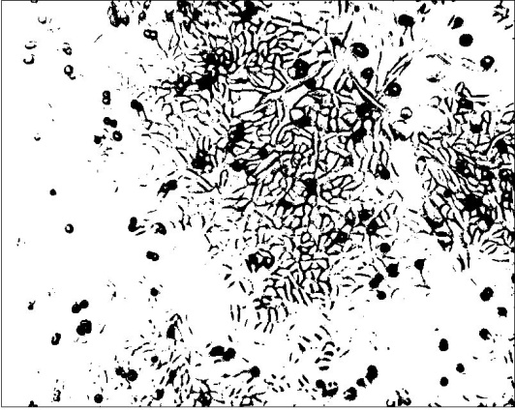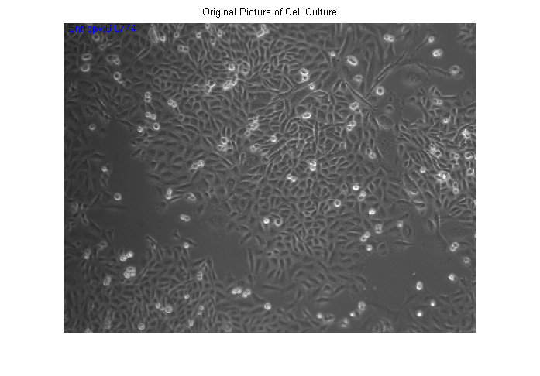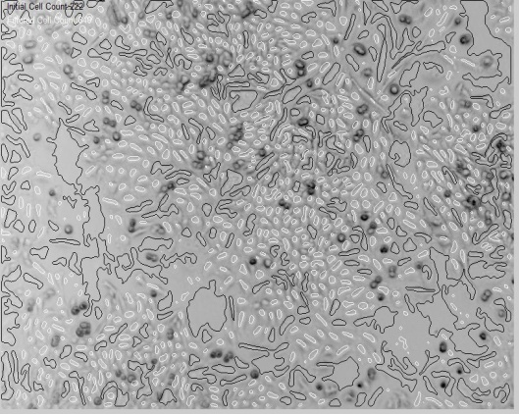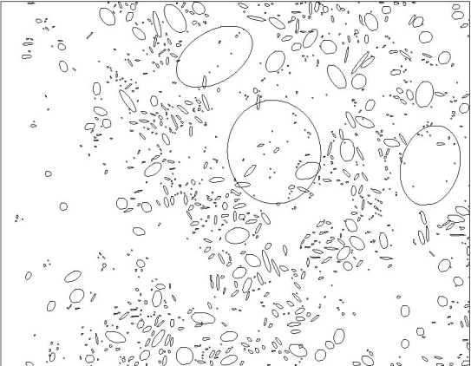 Sample 2 contained a confluent sample of BAECs that were uniform in size and shape. A manual count of 884 cells was obtained for this sample. The sample process for this image was used for ImageJ, which returned a value of 994 cells. While it seems at first glance that this is a much more accurate count compared to the previous sample, a look at the output image from ImageJ allows a much different conclusion to be drawn. Again, as in the first sample, many of the boundaries were drawn around salt-and-pepper noise. There were also extremely large boundaries found which correspond to a large group of cells, but this problem is much less severe than in Sample 1. Overall ImageJ does a reasonable job at accurately defining less than one-quarter of the cells in this image. See figure 11 for the comparison of the original image to the cell boundaries produced by ImageJ.

**Figure 11**: From left to right, top to bottom: A representative image of BAECs, in grayscale, that image thresholded, the algorithms result of 840 cells, and ImageJ’s result of 994 cells, compared to a manual count of 884 cells.

Because this sample is confluent and the relative cell size in pixels is small, the algorithm modified its selection criteria for cells to take the initial count of cells and filter our all of the larger cells that are most likely dead space in the image. Looking at Figure XX shows that the algorithm was reasonably successful at this task. The cells, which were counted, are in white while the cells that were filtered out are shown in black. As seen in the image, the algorithm did filter some actual cells out of the data, but with a filtered cell count of 840, this puts the error from manual counting at 5%, the upper bound for our ideal error.

*Sample 3:*

Sample three contained overconfluent BAECs that were uniform in shape and size but contained a large light gradient from left to right in the image. A manual count of 3456 was taken for this culture. With the relative confluence between this sample and the previous one being on the same order, the major factor in determining cell boundaries in this sample was the light gradient present in the image. While hard to see with the naked eye in the original image of 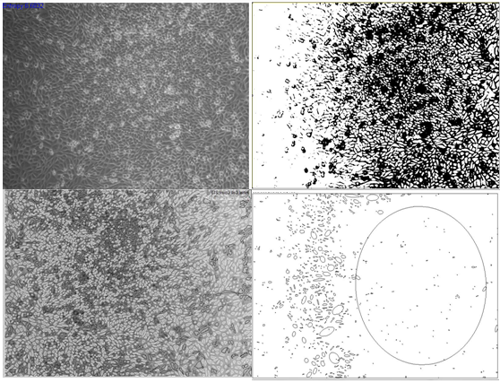Figure 12, the thresholded sample shows a much brighter left side than right side. If we compare the relative accuracies of ImageJ in three bands, the left, center, and right, then some counting issues become apparent. In the far left field, ImageJ again reports boundaries on only the noise in the image. The center of the image is the only portion of the image that ImageJ analysis accurately quantifies. Boundaries are drawn around cells and while the relative sizes do not necessarily accurately compare to the actual cell size, ImageJ does still count them as cells. The right field of view is the darker side of the image and ImageJ returns this as one very large cell. It is uncertain why the program has a tendency to try to draw boundaries of this magnitude, but it forces ImageJ to return a very unsatisfactory result of 770 cells.

**Figure 12**: From left to right, top to bottom: A representative image of BAECs, in grayscale, that image thresholded, the algorithms result of 3125 cells, and ImageJ’s result of 770 cells, compared to a manual count of 3456 cells.

Because of the confluence of this sample and relative cell size, the algorithm again modified its selection criteria to search for smaller cells and filter out all larger ones. Using median filtering allows the algorithm to partially attenuate the bright left field of the image, and because of this, has no problems imaging the left field. The only issue in counting the cells in this image was a particularly dark spot in the upper center portion of the image. The algorithm failed to count these as cells, which led to its slightly less accurate count of 3125, a 9.5% error in manual counting. This still meets the marginal requirements of less than 10% error laid out in the initial goals for the algorithm. This sample is somewhat of a worst-case scenario, with uneven lighting, over-confluent cells in culture, a small pixel area per cell, and dark and bright spots in the image. Through all these processing challenges, the algorithm held to less than 10% error to a manual count, where, by comparison, ImageJ returned a value that showed an error of over 400%.

*Shortcomings and Solutions (Future Iterations)*

While in general the cell-counting algorithm is accurate, there are several shortcomings to its current design. These shortcomings can lead to drastically inaccurate results in the hands of someone unfamiliar with the system. This section is dedicated to altering the algorithm as to minimize these risks, making the cell counting process entirely automatic.

The first step is to have the user input an image that the algorithm will correctly read, in this case, a dark background with illuminated cells. This is not always the case for images of cells, and with the current iteration of the algorithm, the image needs to be manually inverted or the algorithm will count only the space between cells. In future iterations of this algorithm, a plot of the intensities of the histogram will be analyzed to determine whether the image needs inversion before filtering. This seems like a simple feature to implement, for instance when the bell curve of intensity lies above a certain point to invert the image, but relative confluence of an image can vastly effect the intensity distribution of the data, which can even lead to a bimodal distribution of intensity. Care needs to be taken in this step to ensure only those images needing to be inverted actually are.

Each step in the image processing cycle needs to be optimized to allow the most accurate cell count to be made after thresholding. The values that need to be optimized are neighborhood size for the median filter, number of iterations of the median filter, and threshold values. In respect to neighborhood size in the median filter, a larger median filter removes more of the speckling present in a processed image at the risk of removing actual cell data. When the cells are large in pixel area compared to the noise, using a large neighborhood allows for crisp, accurate outlines of all the cells. When the cells have a small pixel area, a larger neighborhood tends to clump cells into aggregate groups and inaccurately outline and count them. Where the current system increments neighborhood size in an effort to obtain a user input desired ration between the standard deviation and the mean, this is at best a coincidental arbitrary measurement of the accuracy of boundaries within an image. Future iterations will compare data between cycles of neighborhood size to determine if speckle, or very small area particles, is being removed from the boundary conditions and if cell aggregation within a boundary is kept to a minimum.

An interesting addition to the neighborhood sizing in the algorithm came in the first realization of the algorithm (analysis was done using the third realization). Neighborhood size could be varied independently in the vertical and horizontal directions. This allows the algorithm to save valuable computational time while filtering only in the direction with change in intensity. In essence, by giving the algorithm the ability to change the neighborhood size over the image, a much better defined cell outline could be made on cells in any orientation. The current version uses a square matrix as this provides a reasonable amount of accuracy, but this is not the optimal case. Future iterations of this algorithm will use spatial gradients to determine the optimal neighborhood size on a pixel-by-pixel basis. The neighborhood size and shape is also affected by both the orientation and shape of the cells being counted, and the boundary data after each iteration can be taken into effect when creating the neighborhood matrix.

Optimizing the number of iterations of the median filter is an interesting topic to consider. For the current iteration, the number of cycles has been fixed at four. Throughout our analysis, extensive testing of the median filter was conducted and it was found that there were marginal changes after four iterations of the filter. By increasing the number of iterations of the filter, one can increase the “muddiness” or blurring of crisp lines in the image. This was done with the algorithm to keep the system from counting organelles as cells, but it also has a tendency to obscure cells, which are in bright or dark spots (see sample 3). By varying the number of filters and running analysis on the resulting intensity histograms, it may be possible to optimize the number of iterations of the median filter on a case-by-case basis to account for dark and bright spots in the data, as well as extremely well defined organelles within the cell.

Thresholding is another feature that is currently implemented manually before any analysis takes place. It is up to the discretion of the operator to determine the optimal thresholding value, which can often be the difference between an accurate and inaccurate count. While general guidelines have been set regarding the means to determine a decent thresholding value, future implementations of the algorithm will choose a threshold value automatically. The algorithm will use intensity information obtained from the image after the completion of filtering. In addition to the automatic selection of the threshold value, the future version of this algorithm will implement a dynamic threshold. This dynamic threshold will vary the value of the thresholding depending on the area of the image, effectively eliminating the negative effects of dark and bright spots and light gradients on the image.

Finally, the current algorithm concludes its iterations when a desired ratio of standard deviation and mean of cell size has been reached. This is a relatively arbitrary method of deciding completion of the algorithm with little grounding in biology or image processing, but seems to work well in practice. Future iterations will follow one of two paths to correct his current issue. The first path conducts tests to see if this ratio is an experimentally sound way of determining goodness of fit of the boundaries and cells and if this ratio can be produced automatically by the algorithm on a case-by-case basis. The second tests if there is another, better metric by which to measure efficacy of the filtering to produce an accurate image.

**Conclusion**

The proposed cell counting algorithm in this report improved upon a challenging aspect of biomedical sciences – cell counting. Our algorithm improves upon what has already been established, from automatic cell counting machines to programs in ImageJ. At the beginning of the report, the goal was to create an algorithm which held to within 5-10% accuracy relative to a manual cell count. To do this, the algorithm employed median filtration, histogram equalization, thresholding, and Moore neighbor boundary tracing. Several cell images were analyzed which differed in cell size, shape, resolution, and confluence. Each manual cell count was compared to the cell count output of the proposed algorithm and to ImageJ’s cell counter. For each image, the proposed algorithm had an average error <10% compared to ImageJ’s error of over 100%. Based on this analysis, the proposed algorithm fulfilled expectations as a viable cell counting device. Future analysis will be necessary to decrease the cell counting error to an optimal level of less than 2%.

**APPENDIX A**

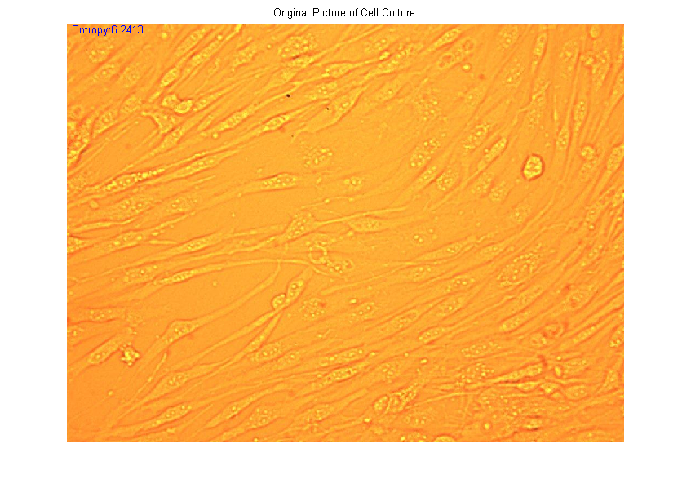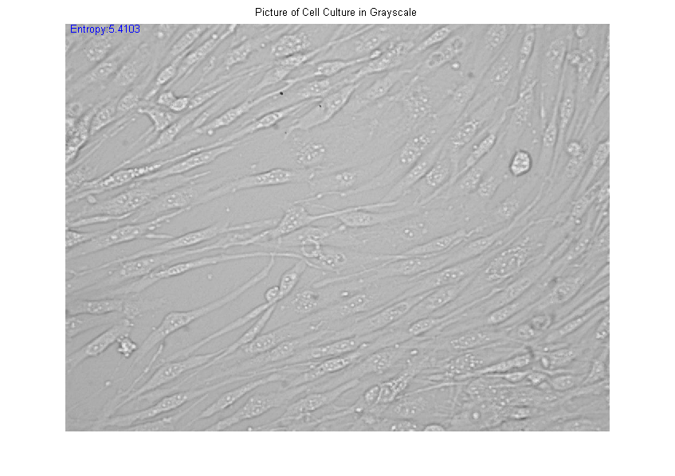Bovine Endothelial Cell Sample #1

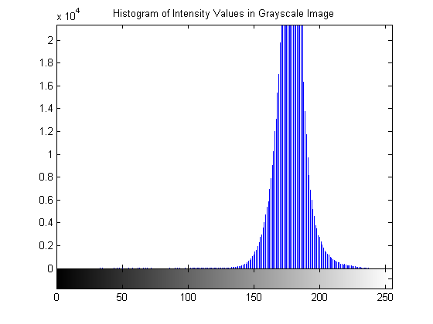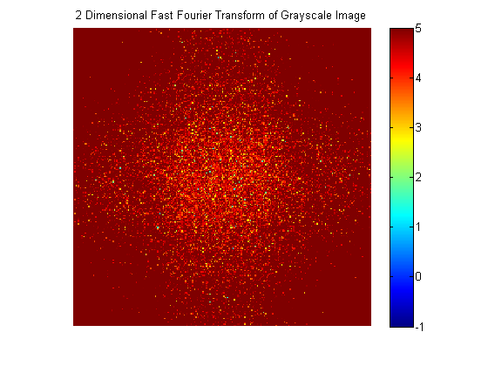

Bovine Endothelial Cell Sample #2

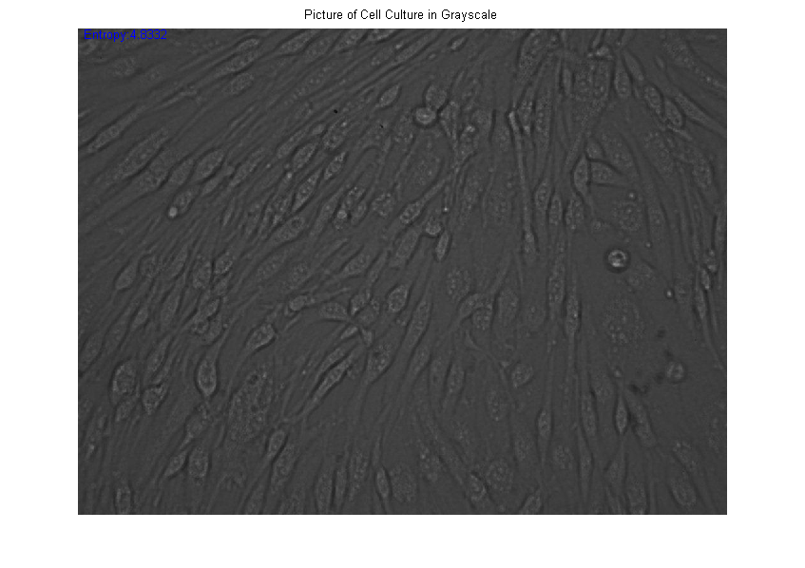

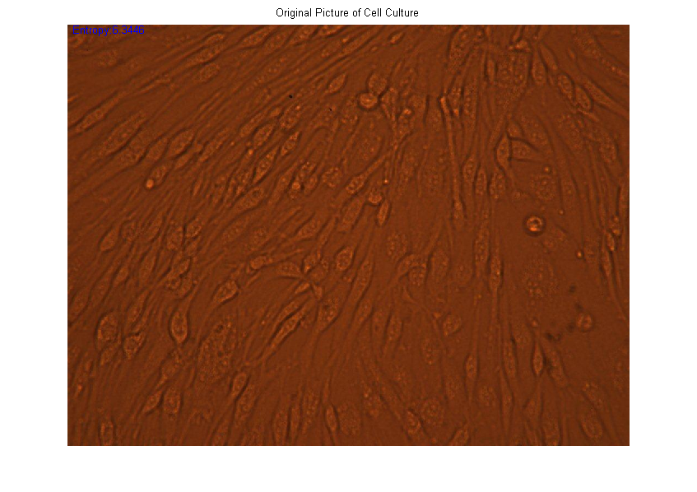

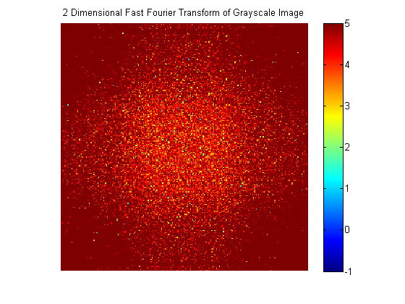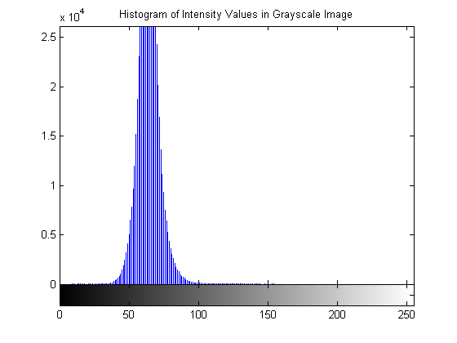

Bovine Endothelial Cell Sample #3

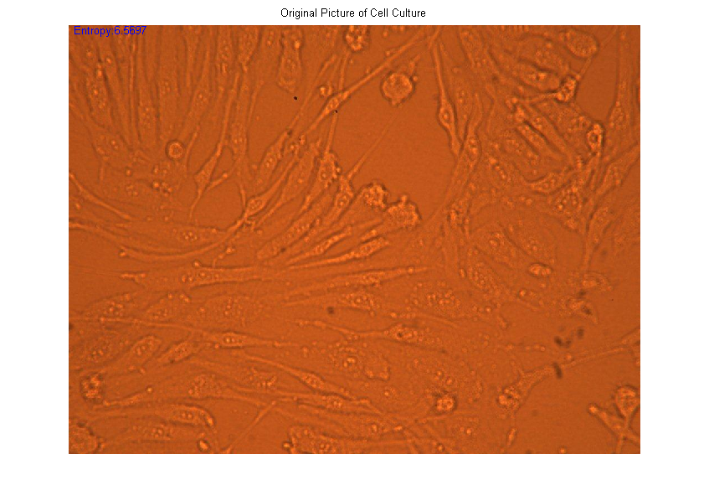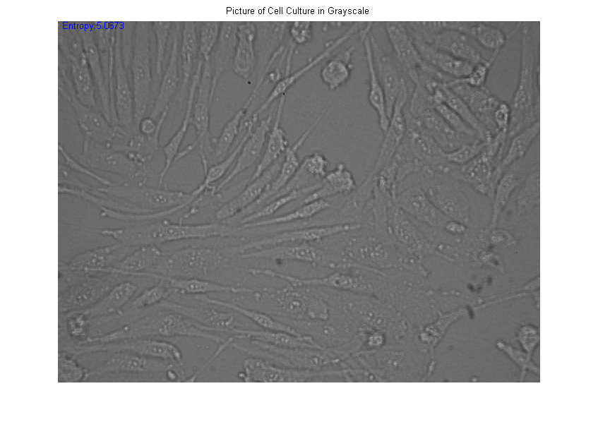

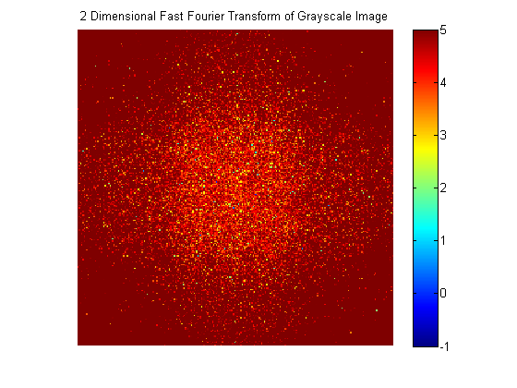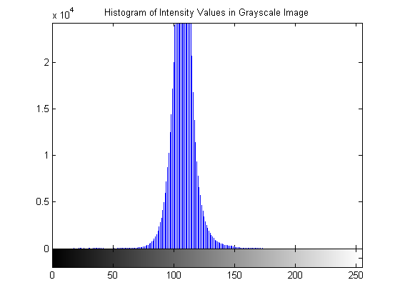

Bovine Aortic Endothelial Cell Sample #1

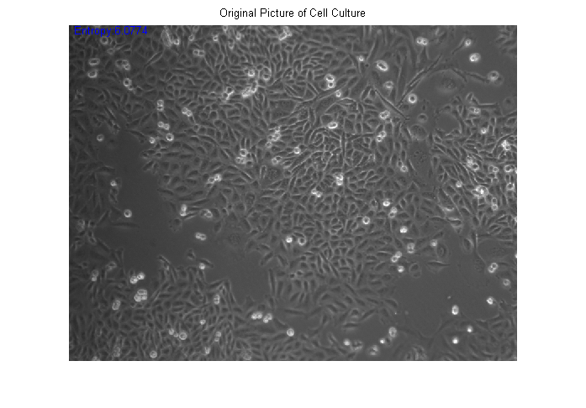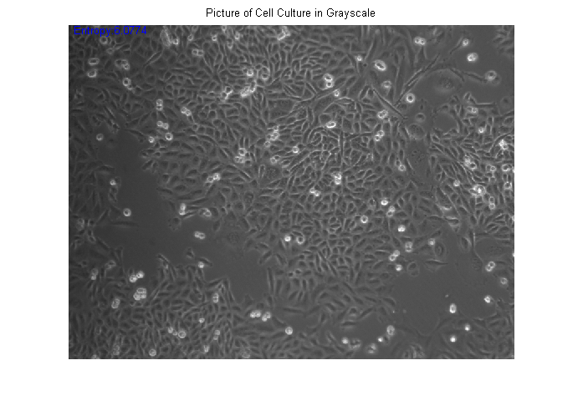

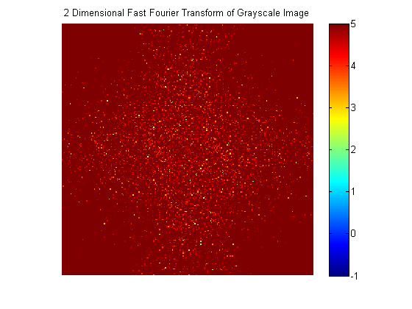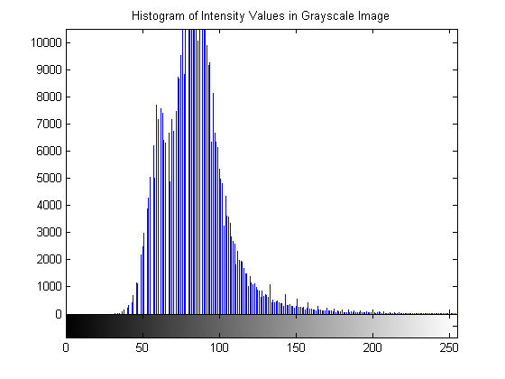

Bovine Aortic Endothelial Cell Sample #2

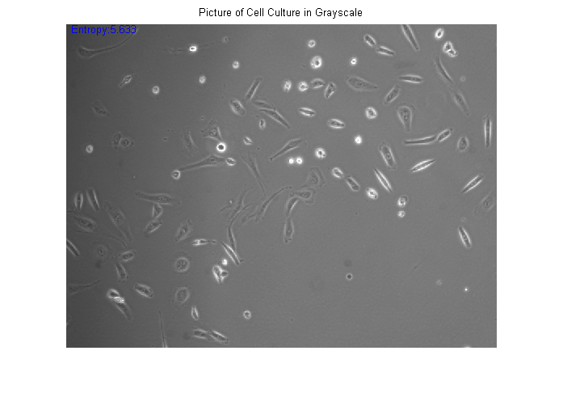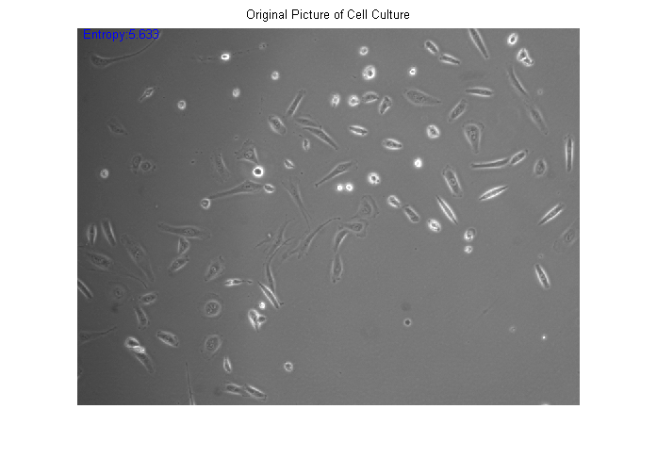

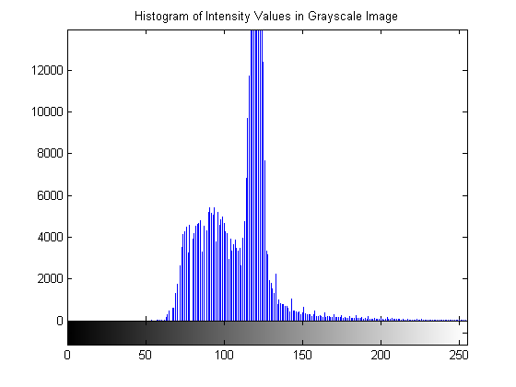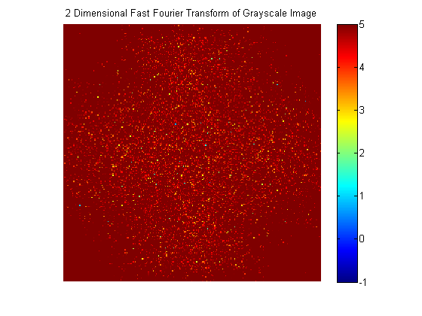

Bovine Aortic Endothelial Cell Sample #3

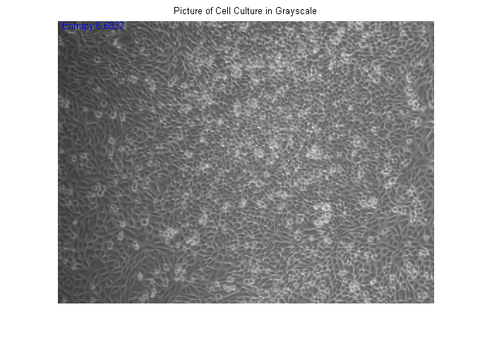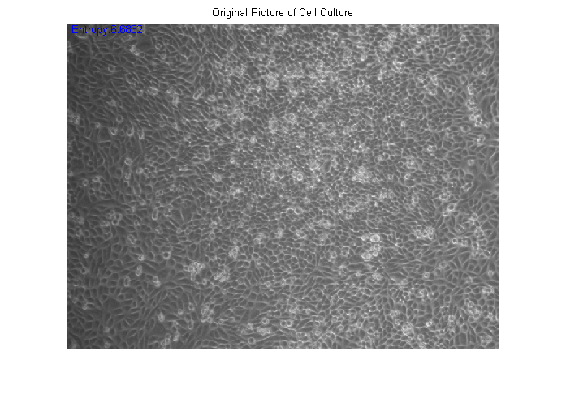

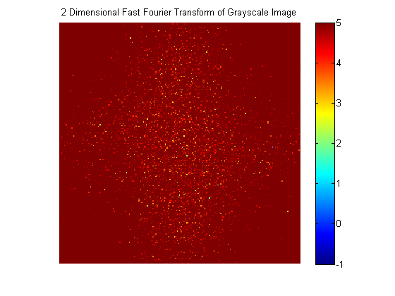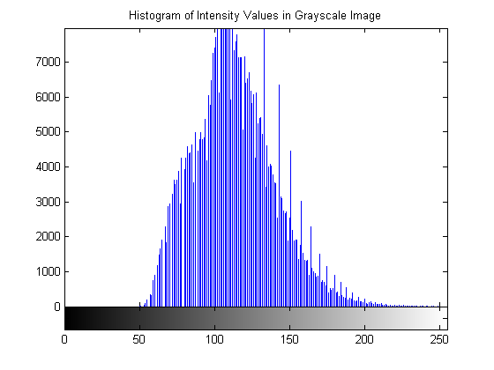

**APPENDIX B**

%% BME 4783 - Medical Imaging Modalities

%

% Investigate Effects of Commutivity of Filters.

%

% Daniel Amante, Jarel Cohen, Robert MacGregor, Ashutosh Priyadarshy

% University of Virginia

% Spring 2011

%%% File loading

% Load an Image into a matrix I.

sample = imread('cell2.jpg');

%sample = imread(filename);

originalSample = sample;

% Convert the Image to grayscale.

sample = rgb2gray(sample);

originalSample = sample;

%%% Conditioning parameters.

% Pixel Neighborhood Size for median filter.

nhood = [9 9]; % Note: change each iteration?

% No. times we will median and adaptive histogram filter succesively.

filterCycles = 4;

% Binary thresholding of the grayscale image.

gray2bin = 190;

%% Perform Cascading Filtration.

% Perform the medfilt2 filtration filterCycles times.

for cycle = 1:filterCycles

% Apply Median Filtration pixel-wise in a n'hood of dim nhood.

medFiltLast = medfilt2(sample, nhood);

% Set the twice filtered image to be equal to the sample.

sample = medFiltLast;

end

% Perform the adapthisteq filtration filterCycles times.

for cycle = 1:filterCycles

% Apply Adaptive Histogram Equalization.

adaptHistEqLast = adapthisteq(sample);

% Set the twice filtered image to be equal to the sample.

sample = adaptHistEqLast;

end

% Save the cascaded version as a seperate matrix.

sampleCascade = sample;

sampleCascadeBin = sampleCascade > gray2bin;

%% Perform back-to-back filtration (original method).

% Reset to the originalSample.

sample = originalSample;

% Perform the double filtration filterCycles times.

for cycle = 1:filterCycles

% Apply Median Filtration pixel-wise in a n'hood of dim nhood.

medFiltLast = medfilt2(sample, nhood);

% Apply Adaptive Histogram Equalization.

adaptHistEqLast = adapthisteq(medFiltLast);

% Set the twice filtered image to be equal to the sample.

sample = adaptHistEqLast;

end

% Save the back to back version as a separate matrix.

sampleBack2Back = sample;

sampleBack2BackBin = sampleBack2Back > gray2bin;

hold on

plot(sum(sampleBack2BackBin == sampleCascadeBin)./768, 'b')

xlabel('Horizontal Pixel')

ylabel('Percent Match in Horizontal Row')

title('Matching Between Cascade Filtration and Back to Back Filtration');

axis([0 1024 0 1.1])

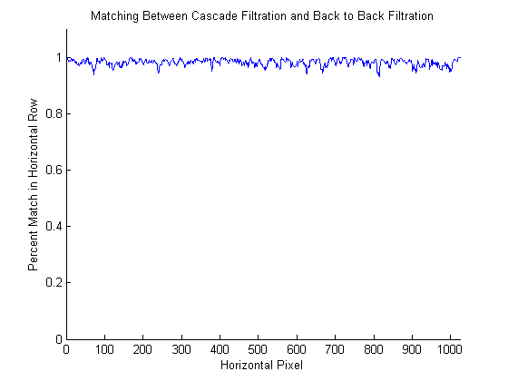

**APPENDIX B**

Listing and description of digital files accompanying this report:

Images:

1. cell1.jpg – BECS Cells ‘Sample #1’
2. cell2.jpg - BECS Cells ‘Sample #2’
3. cell3.jpg - BECS Cells ‘Sample #3’
4. Confluent.tif - BAECS Cells ‘Sample #1’
5. Nonconfluent.tif - BAECS Cells ‘Sample #2’
6. Overconfluent.tif - - BAECS Cells ‘Sample #3’

Matlab Functions:

1. CellCounterFinal.m
2. CellCounterOtherOneWhatsItCalled

**References**

1. "Countess Automated Cell Counter." *invitrogen*. Life Technologies, n.d. Web. 9 May 2011. <http://www.invitrogen.com>.
2. "Automatic Cell Counter." *Chemometec*. Nucleocounter, n.d. Web. 9 May 2011. <http://www.chemometec.com/en-GB/global>.
3. "Scepter 2.0 Handheld Automated Cell Counter." *Millipore*. N.p., n.d. Web. 9 May 2011. <http://www.millipore.com/catalogue/module/c85360>.
4. Markiewicz, T, and C Jochymski. "Automated recognition and counting of the immunoreactive neuroendocrine cells in chronic gastritis (the preliminary study)." *Folia Histochem Cytobiol* 47.4 (2009): 685-90.
5. Bewes, JM, and N Suchowerska. "Automated cell colony counting and analysis using the circular Hough image transform algorithm (CHiTA)." *Phys Med Biol* 53.21 (2008): 5991-6008.
6. Kachouie, N, and L Kang. "Arraycount, an algorithm for automatic cell counting in microwell arrays." *Biotechniques* 47.3 (2009): 13-19.
7. Huang, Y, X Zhou, and M Lipinski. "A computational framework for studying neuron morphology form in vitro high content neuron-based screening." *J Neurosci Methods* 190.2 (2010): 299-309.
8. Pascut, FC, HT Goh, and N Welch. "Noninvasive detection and imaging of molecular markers in live cardiomyocytes derived from human embryonic stem cells." *Biophys J* 100.1 (2011): 251-9.
9. Scarpa, F, and D Fiorin. "In vivo three-dimensional reconstruction of the cornea form confocal microscopy images." *Conf Proc IEEE Eng Med Biol Soc* 2007 (Apr. 2007): 747-50.